THIS CERTIFIES THAT

# TERRI B. DEATLEY

HAS SUCCESSFULLY COMPLETED

# TITLE IX COORDINATOR TIER 5 CLASS: PREGNANCY OR RELATED CONDITIONS

PRESENTED BY D. STAFFORD & ASSOCIATES (4 HOURS OF INSTRUCTION)

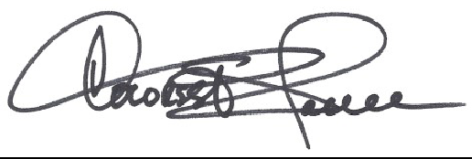

DOLORES A. STAFFORD PRESIDENT & CEO

APRIL 10, 2025 DATE